Experiment # 11

**Cloud Computing**

**Objective:**

* Basics understanding of cloud technology & and cloud computing.

**Theory:**

**A Cloud** is a type of parallel and distributed system consisting of a collection of inter-connected and virtualized computers that are dynamically provisioned and presented as one or more unified computing resource(s) based on service-level agreements established through negotiation between the service provider and consumers.

**Cloud computing** is a model for enabling convenient, on-demand network access to a shared pool of configurable computing resources (e.g., networks, servers, storage, applications, and services) that can be rapidly provisioned and released with minimal management effort or service provider interaction.

When you store your photos online instead of on your home computer, or use webmail or a social networking site, you are using a cloud computing service. If you are in an organization, and you want to use, for example, an online invoicing service instead of updating the in-house one you have been using for many years, that online invoicing service is a cloud computing service. Cloud computing is the delivery of computing services over the Internet. Cloud services, Allow individuals and businesses to use software and hardware that are managed by third parties at remote locations.

**Examples** of cloud services include online file storage, social networking sites, webmail, and online business applications. The cloud-computing model allows access to information and computer resources from anywhere. Cloud computing provides a shared pool of resources, including data storage space, networks, Computer processing power, and specialized corporate and user applications.

**Architecture**

* Cloud Service Models
* Cloud Deployment Models
* Essential Characteristics of Cloud Computing

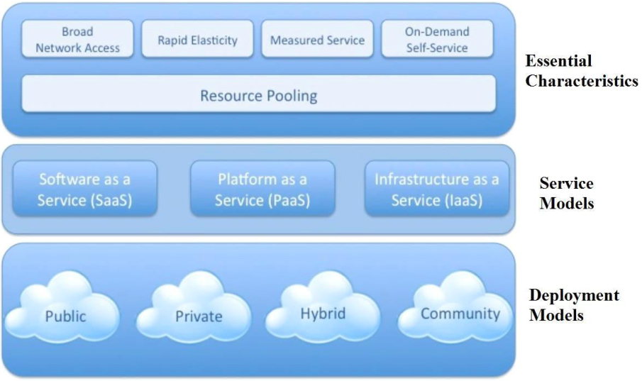

**Cloud Service Models**

1. Software as a Service (SaaS)
2. Platform as a Service (PaaS)
3. Infrastructure as a Service (IaaS)

**Infrastructure as a Service (IaaS):**

* The capability provided to the consumer is to provision processing, storage, networks, and other fundamental computing resources.
* Consumer is able to deploy and run arbitrary software, which can include operating systems and applications.
* The consumer does not manage or control the underlying cloud infrastructure but has control over operating systems; storage, deployed applications, and possibly limited control of select networking components (e.g., host firewalls).

**Platform as a Service (PaaS):**

* The capability provided to the consumer is to deploy onto the cloud infrastructure consumer created or acquired applications created using programming languages and tools supported by the provider.
* The consumer does not manage or control the underlying cloud infrastructure including network, servers, operating systems, or storage, but has control over the deployed applications andpossibly application hosting environment configurations.

**Software as a Service (SaaS):**

* The capability provided to the consumer is to use the provider‘s applications running on acloud infrastructure.
* The applications are accessible from various client devices through a thin client interfacesuch as a web browser (e.g., web-based email).
* The consumer does not manage or control the underlying cloud infrastructure includingnetwork, servers, operating systems, storage, or even individual application capabilities,with the possible exception of limited user specific application configuration settings.

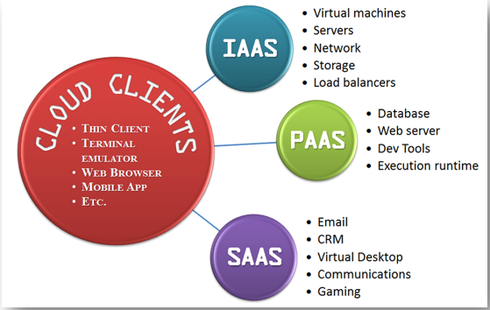

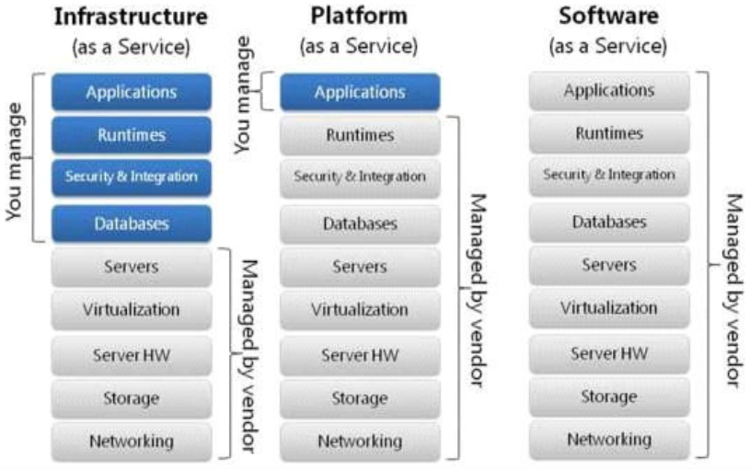

**Lab Tasks**

1. Elaborate the Basics characteristics of the cloud computing.
2. Define the advantages and disadvantages of cloud computing
3. Mention the examples of cloud software use now a day.

**Conclusion**

**______________________________________________________________________________________________________________________________________________________________________________________________________________________________________________________**